**Steps to Access Your Score Report from Student Portal - ACCUPLACER**

The ACCUPLACER Student Portal allows students to request a copy of their test scores. ***Note:*** *If you did not enter an e-mail address when you tested, you will not be able to access your report. Contact us through e-mail:* ***remote-placement@broward.edu***

**Step 1:** Go to <https://studentportal.accuplacer.org/> to access the ACCUPLACER Student Portal. Click where it says:

**“Your ACCUPLACER Score Report”**

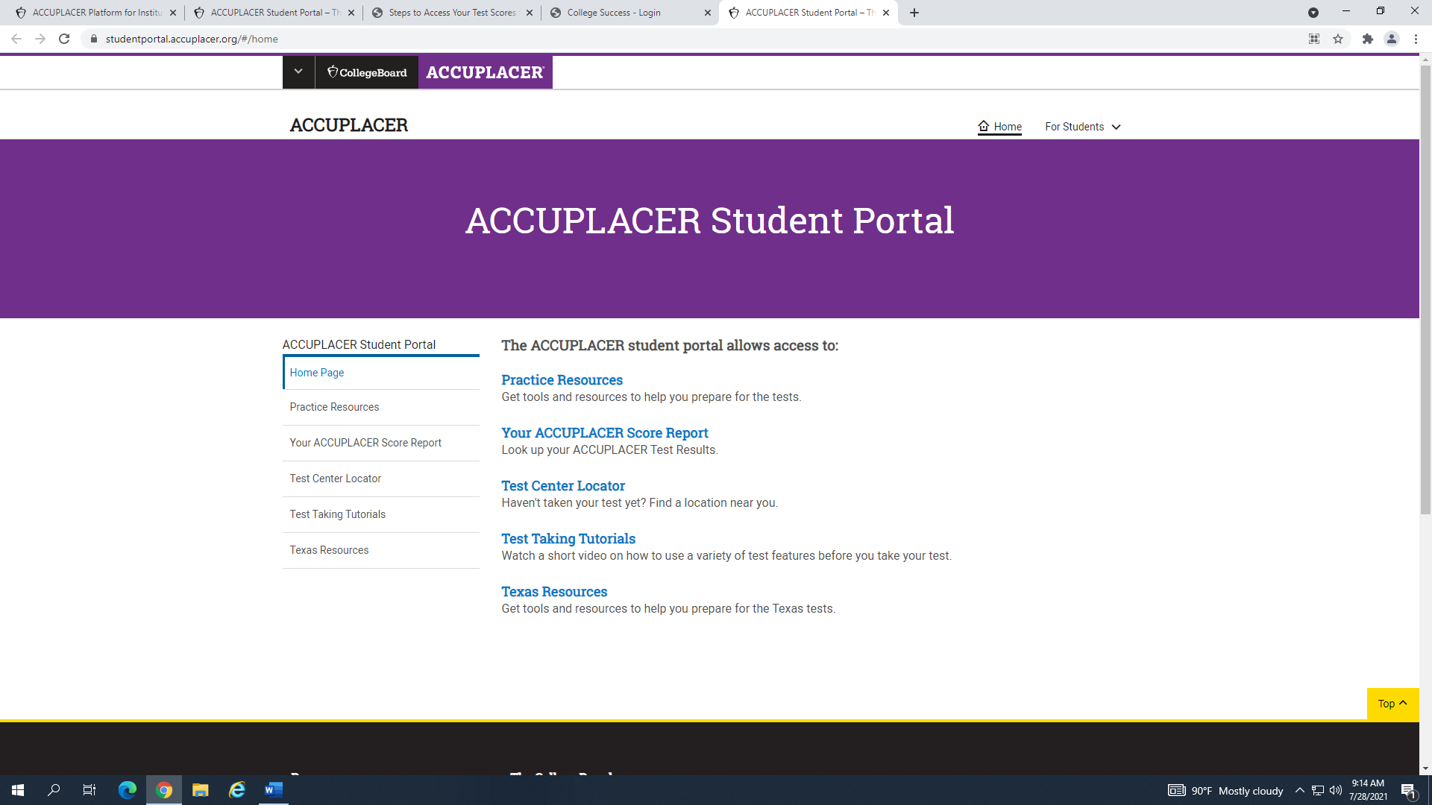

**Step 2:** Under **“Find Your Test Results”** screen, enter the same information that you provide when registering for your test.

Our institution information is as follows:

**Institution Country: United States**

**Institution State: Florida**

**Student Institution: Broward College**

Select **“Search”** once finished.

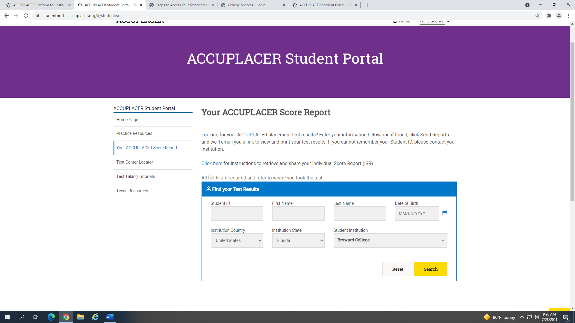

**Step 3:** You should now see a window below **“Find** **Your** **Test** **Results”** that says, **“Search Result”**. Verify that the e-mail address shown is your active e-mail (you will receive your scores through this e-mail).

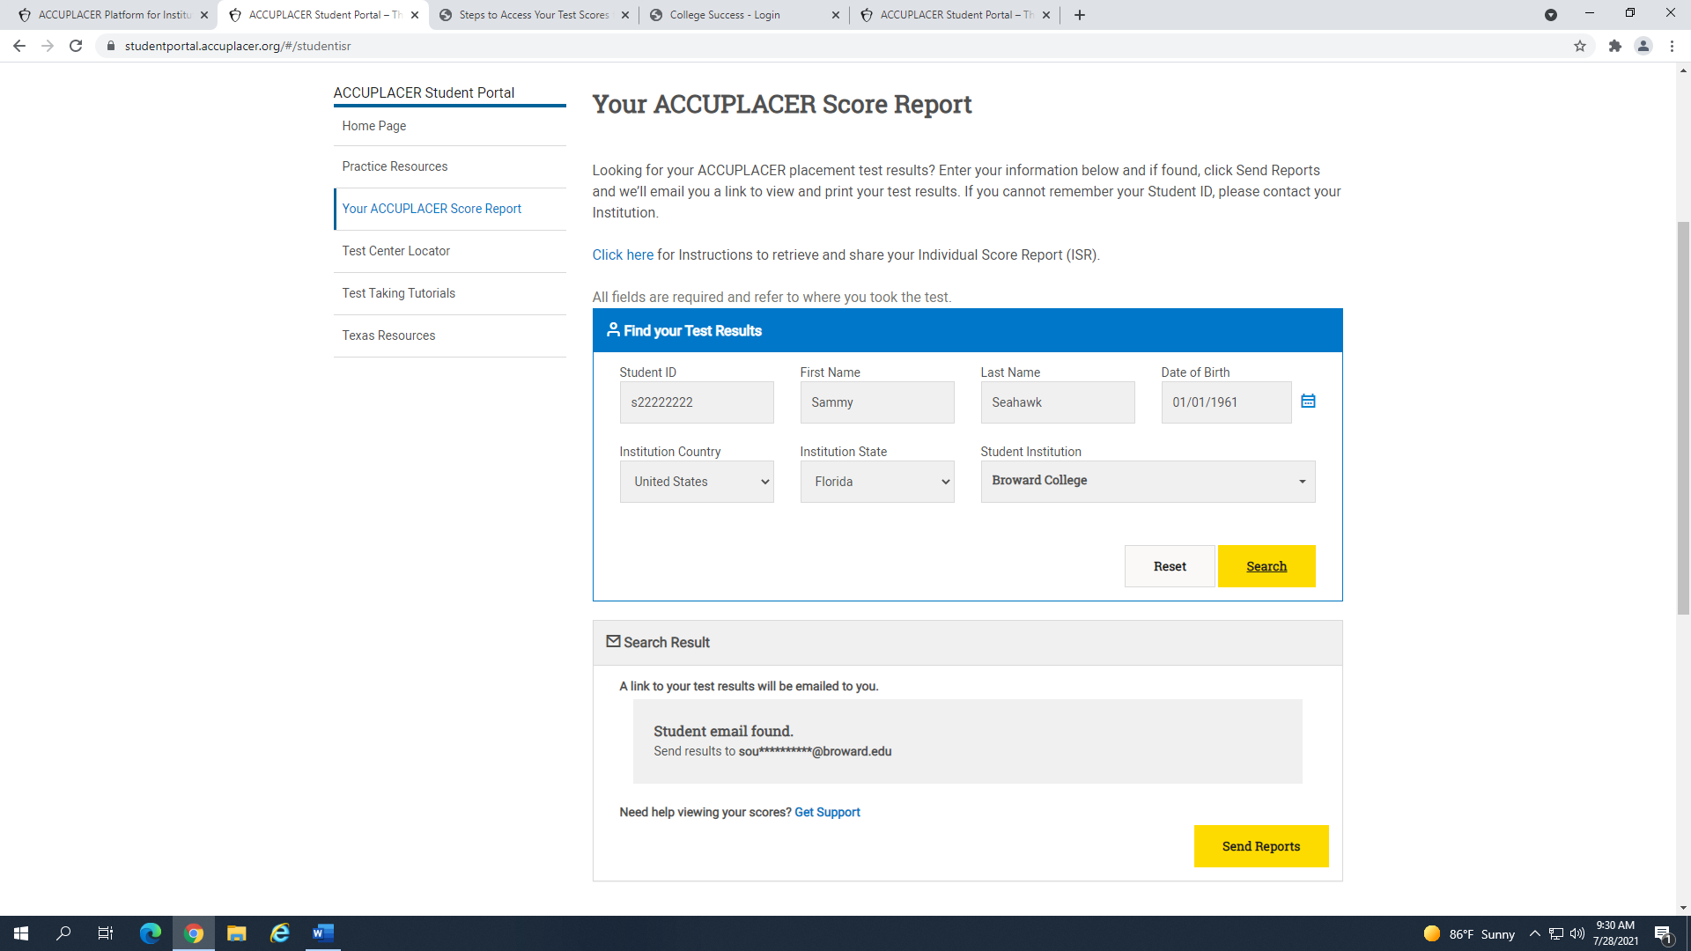

Click **“Send Reports”** to receive an e-mail with your Individual Score Report**. If you are experiencing difficulties during this step, you can contact us through e-mail (**[**remote-placement@broward.edu**](mailto:remote-placement@broward.edu)**) and we will locate your account information for you.**

**Step 4:** Read the College Board Privacy Policy, check the box that confirms you have read it, and choose to Accept.

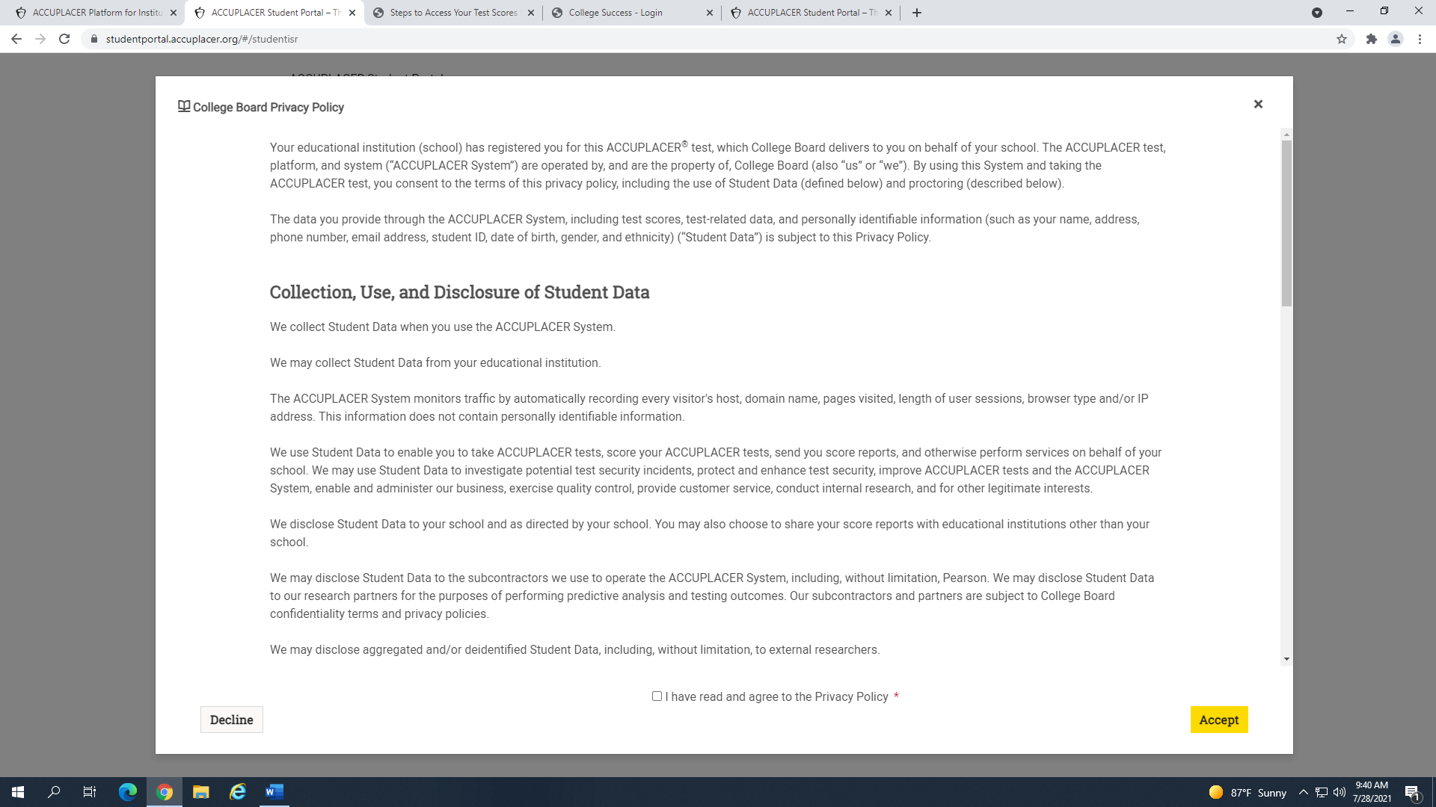

**Step 5:** Check your e-mail for a message from ACCUPLACER with the subject **“Your ACCUPLACER Test Results”**.

Click **“View ISR”**. ***Note:*** *if you do not see it in your e-mail, check your spam.*

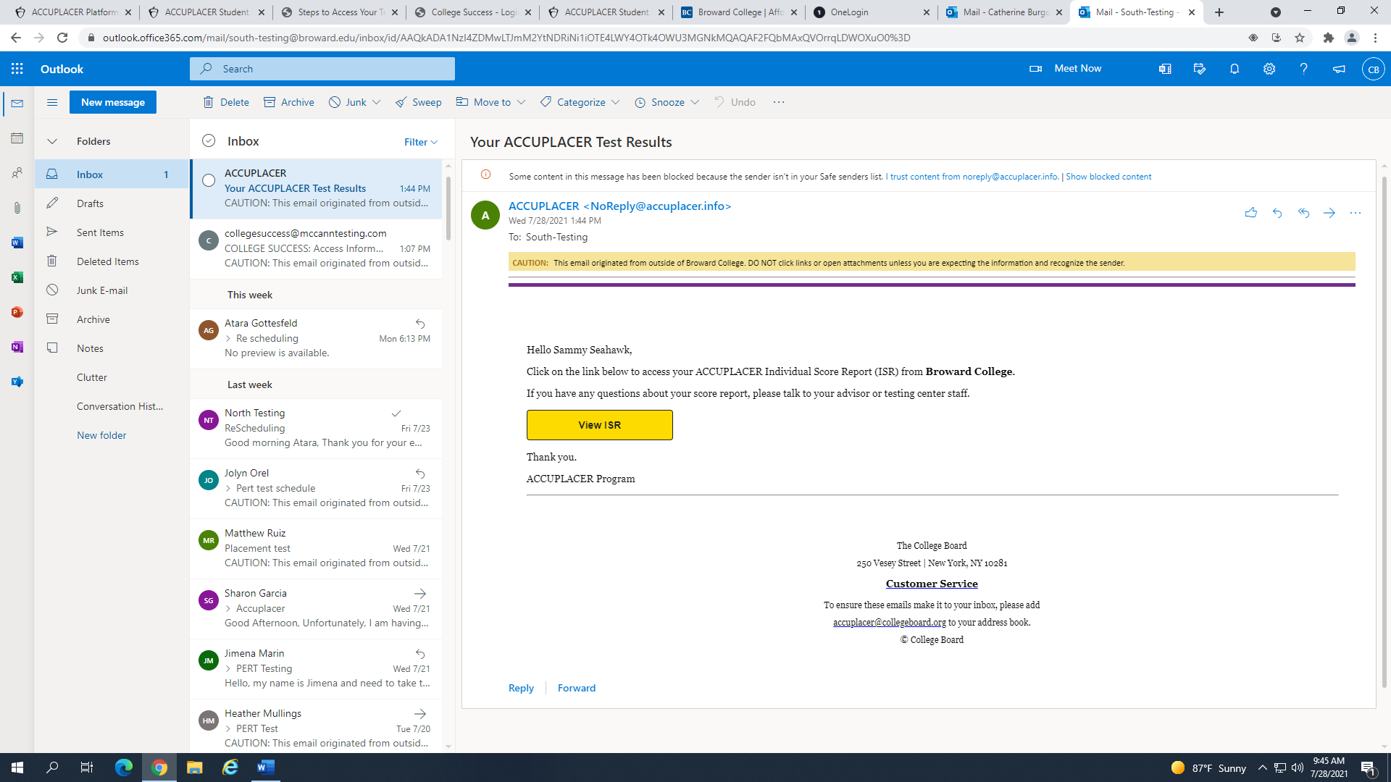

**Step 6:** The system will have you Read and Accept the College Board Privacy Policy one more time before showing your score report.

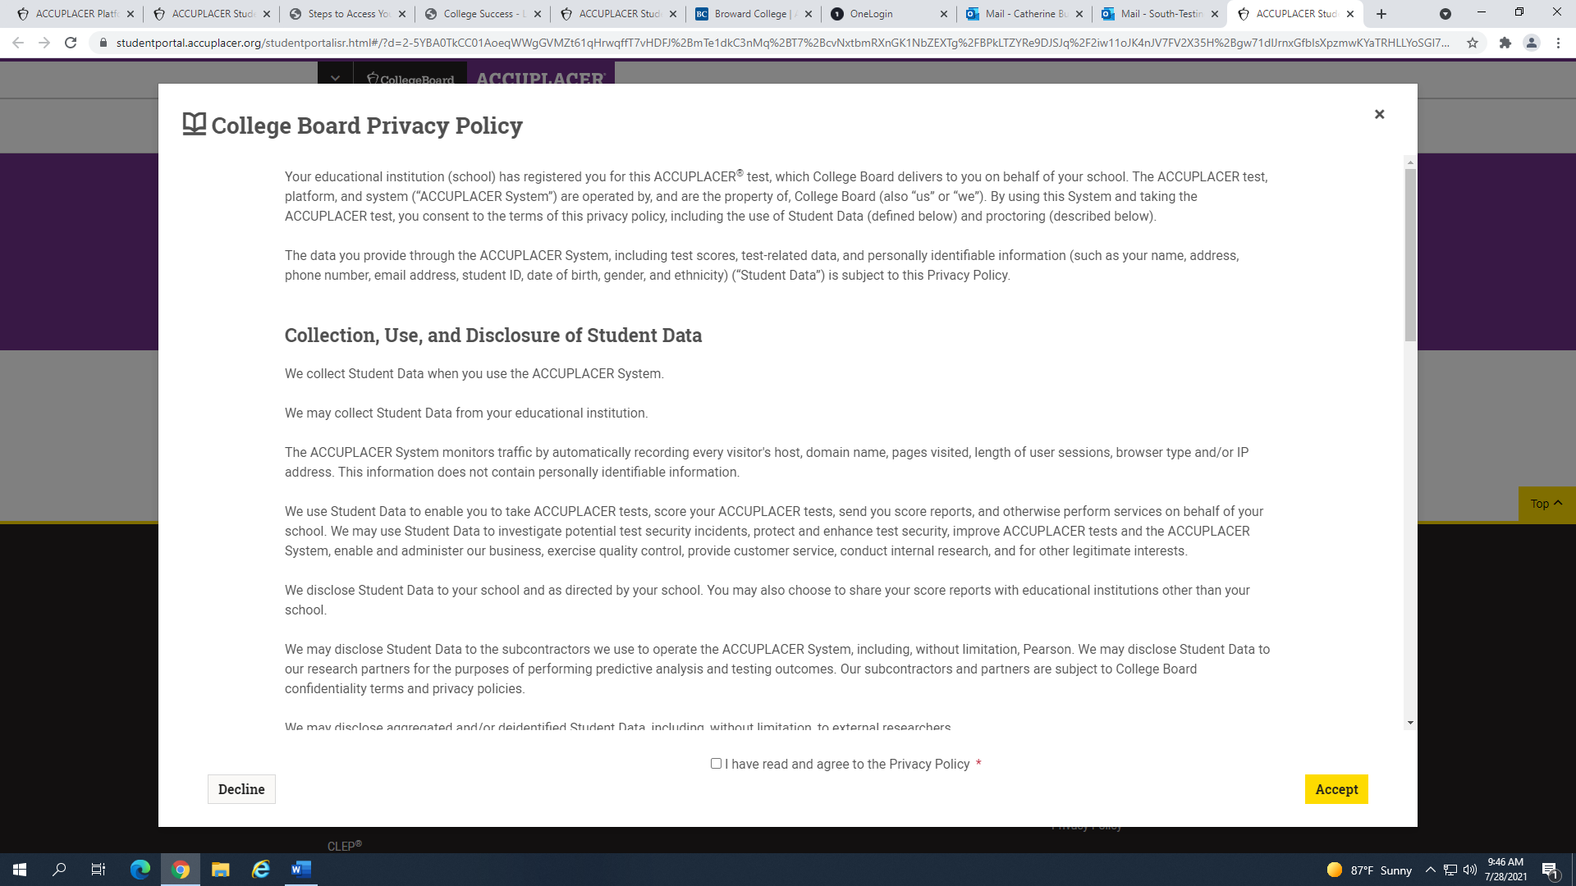

**Step 7:** You will see a report with the date of your test session and scores. To view or print your score report, select

**“View Complete Report”**.

