**Steps to Access Your Score Report from Student Portal – PERT**

The College Measured Success allows students to request a copy of their test scores. ***Note:*** *if you did not enter the correct e-mail address when you tested, you will not be able to access your Student Portal. Contact us through e-mail:* **remote-placement@broward.edu**

**Step 1:** Go to <https://college.measuredsuccess.com/> to access the student portal. If you know your login credentials, enter your username and password information and then click **“Sign In.”** You may proceed with Step 2 (page 3).

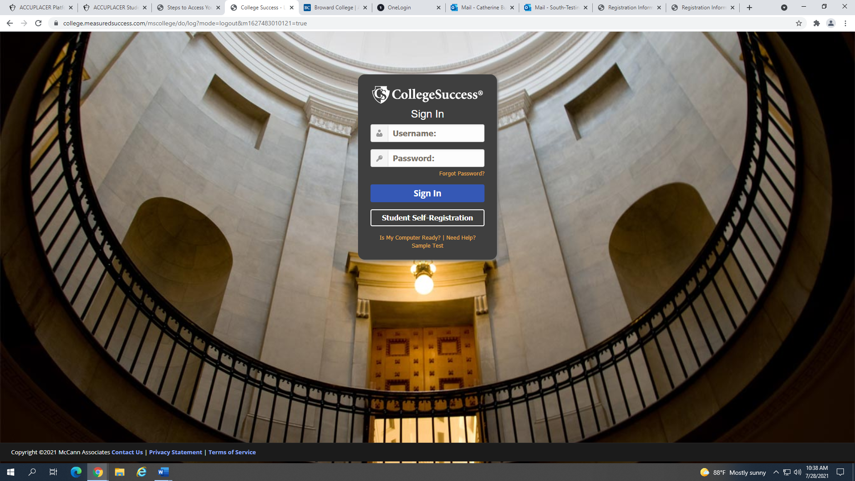

If you do not know your login credentials, click **“Forgot Password?”**

Under **“Forgot your password?”** enter the e-mail address that you used when registering for the exam. Click **“Reset My Password”**.

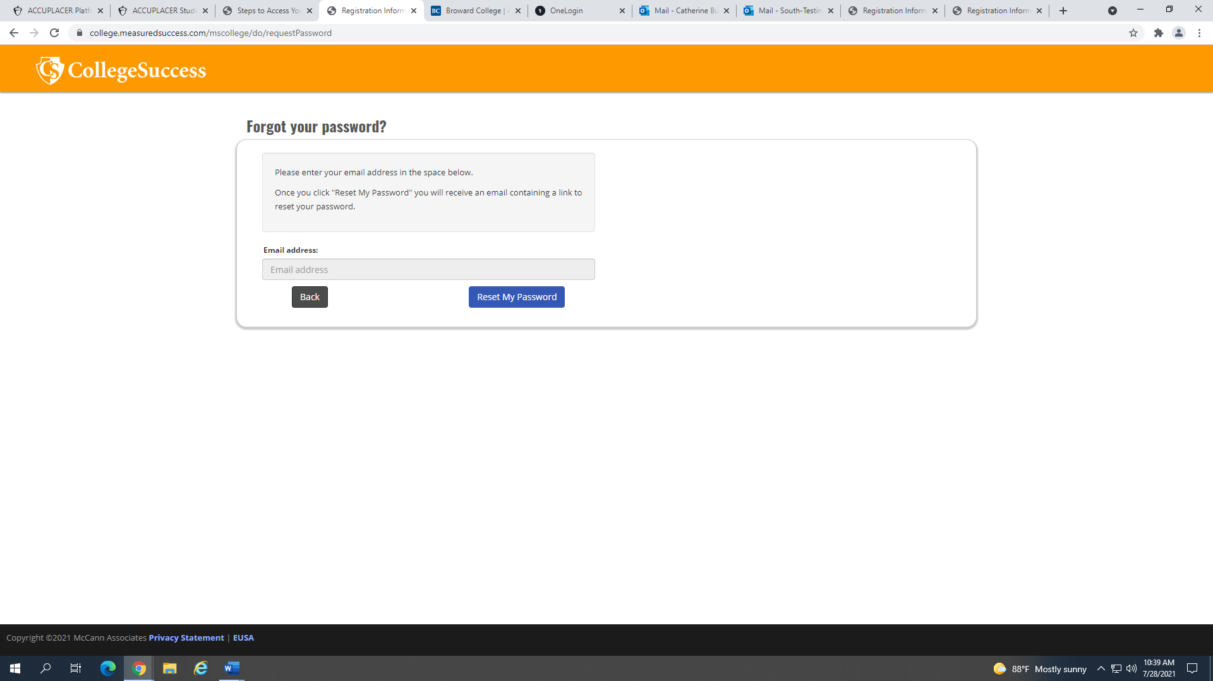

You will receive an e-mail with the subject **“COLLEGE SUCCESS: Access Information”**. Click the link provided in the e-mail. **If you are experiecing difficulties during this step, you can contact us through e-mail (**[**remote-placement@broward.edu**](mailto:remote-placement@broward.edu)**) and we will locate your account information for you.**

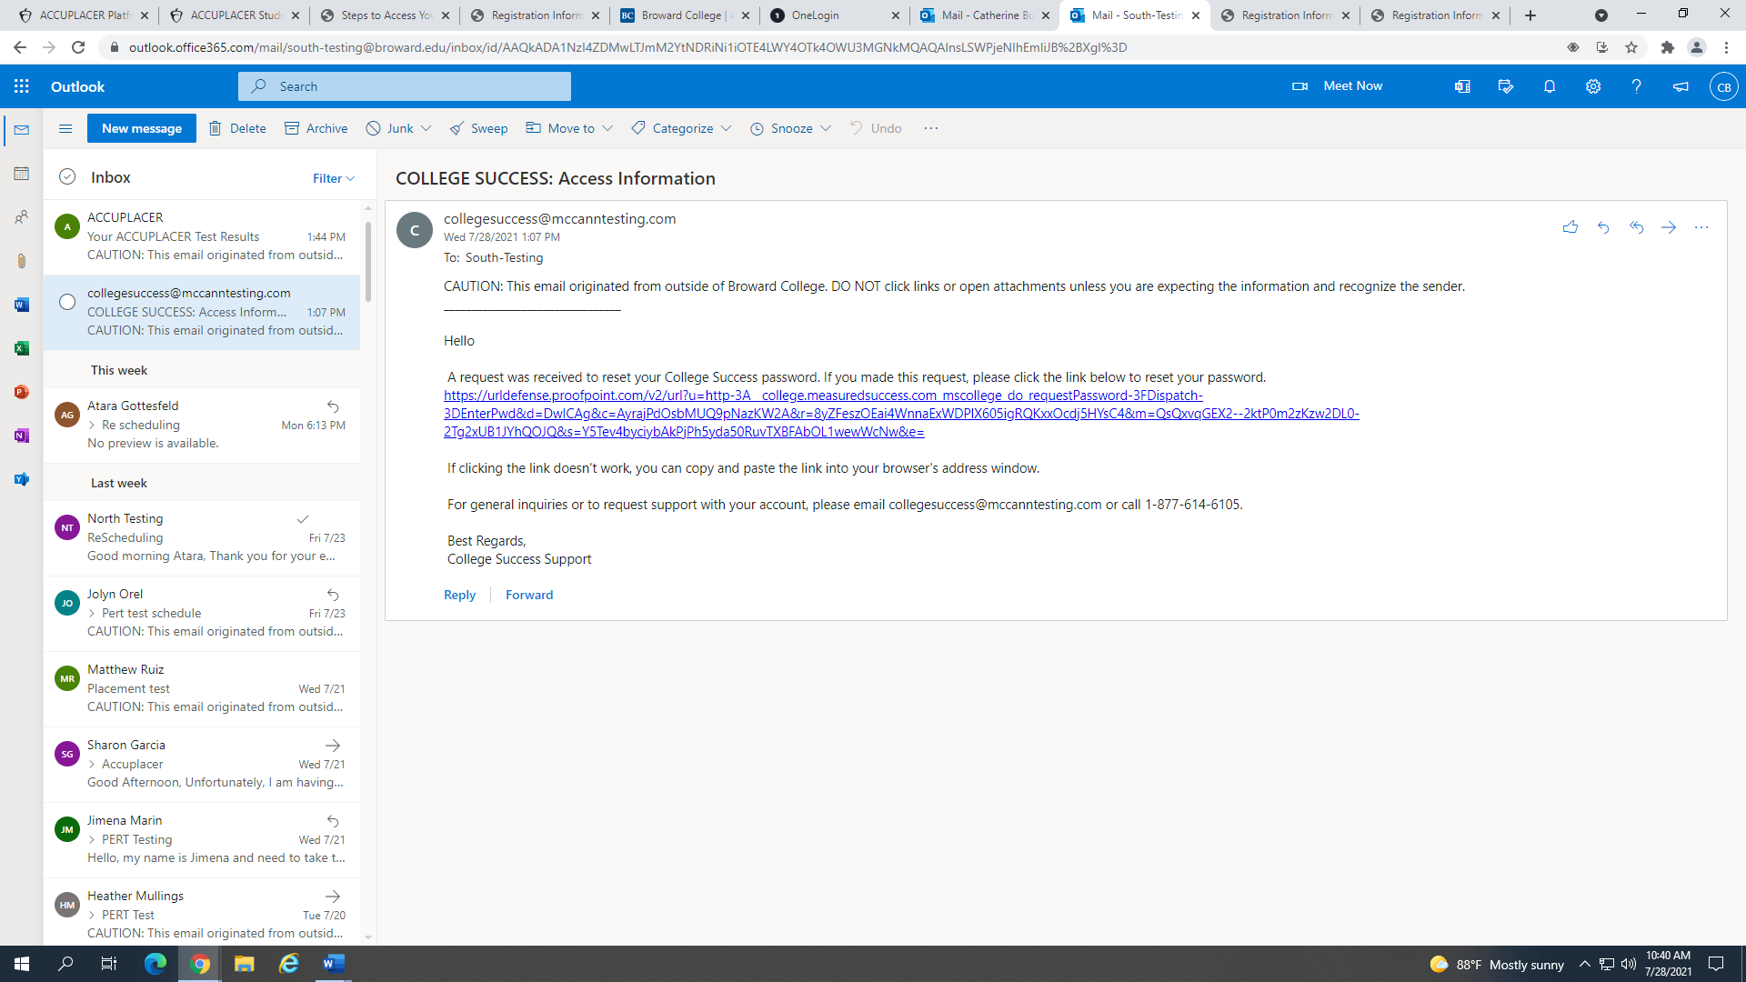

Under **“Change Your Password”**, enter your username and a new password twice. Click **“Change Password”**. You will be redirected to login page. Enter your login information and click **“Sign In”**.

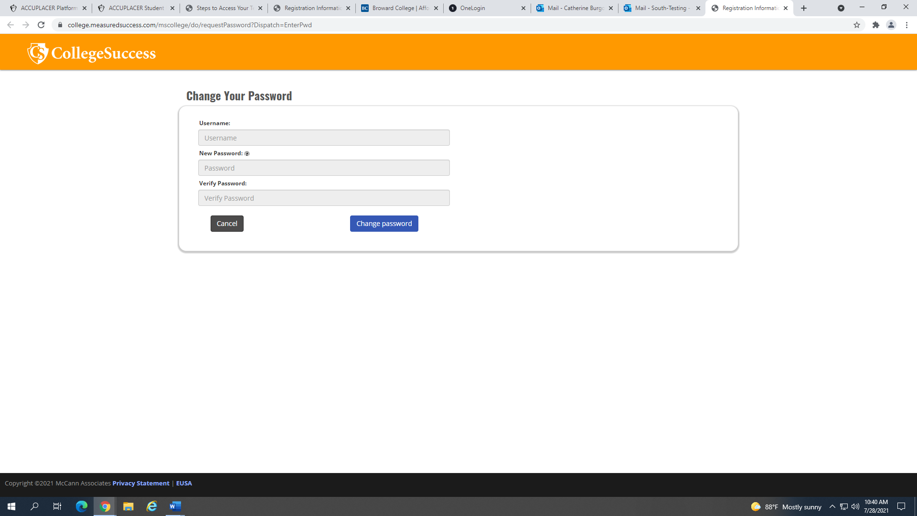

**Step 2:** Accept the College Success Terms of Service to continue.

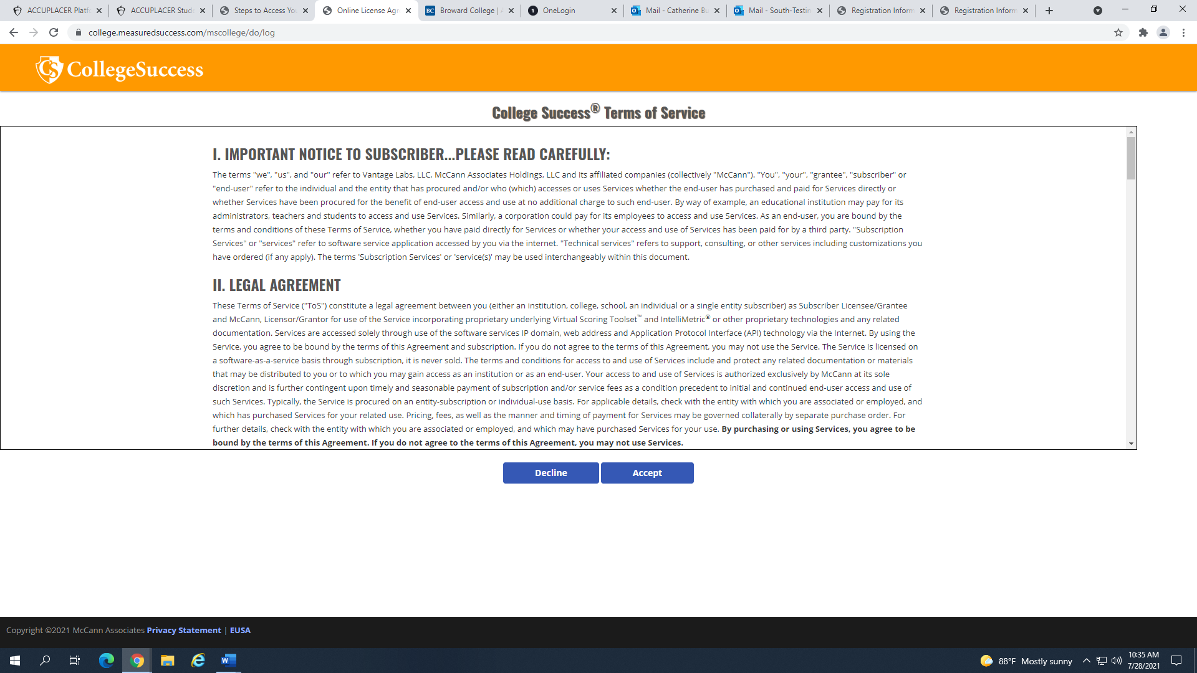

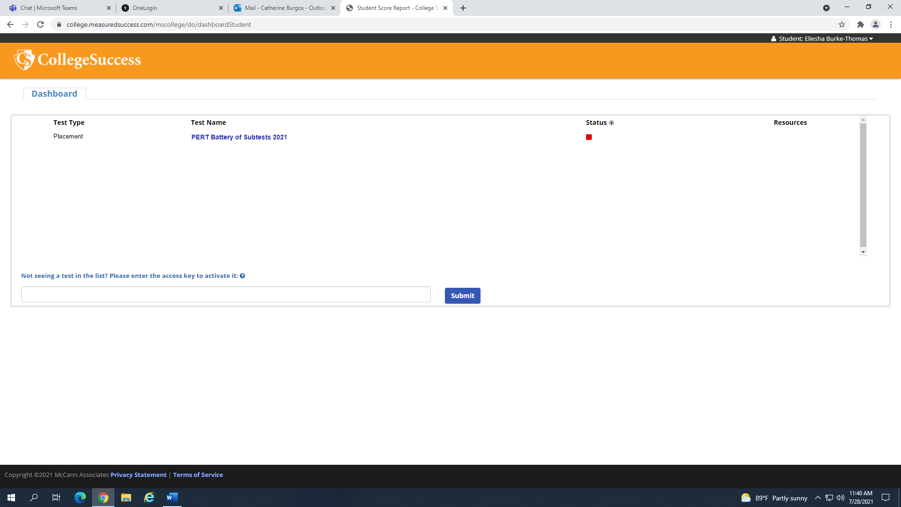**Step 3:** Under **“Dashboard”** you will see a list of all exams taken through College Success. A Sore Report is ready when you see a red square under “Status.” Click on the exam report that you need, and your Score Report will show.

