

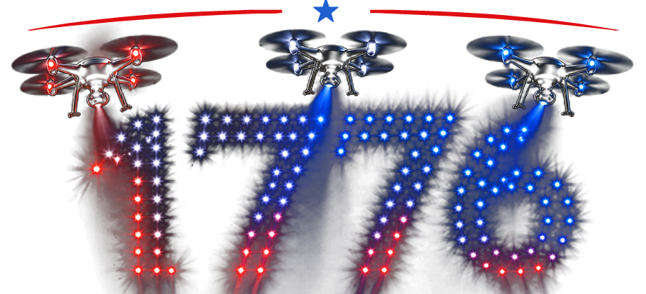
Swarm Intelligence Engineering
Handbook


Note. Reproduced from Top 20 In-Demand Careers in Drone Industry That You Need to Consider Now, by
AscendurePro, 2026 (https://ascendurepro.com/careers-in-drone-industry/). Reproduced with permission.

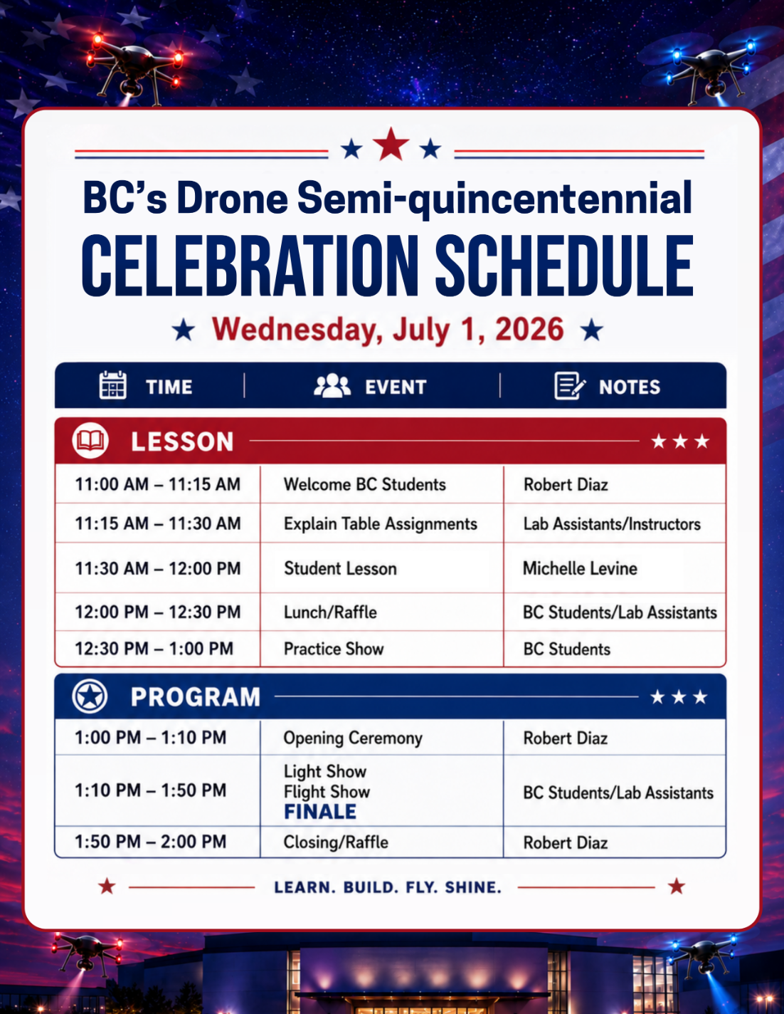
BC’s Drone Semi-quincentennial Celebration

Lesson Plan

Hardware Portion
Note: These drones are “inside” drones and therefore may not be flown outside for any reason. This is a school policy.
Make sure your batteries are at least 80%.
Replace your drone battery if it needs it!

What Should Be On Your Table?
A laptop connected to USB Hub and the USB Hub to 5 - 8 remote controls per side. Please do NOT connect more than eight remote controls.

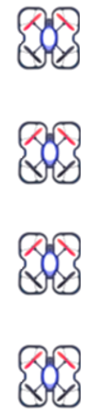
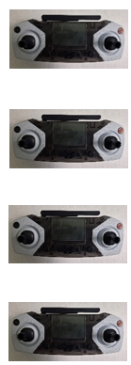
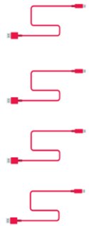
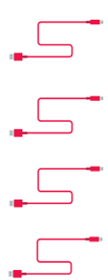
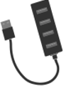


Learning Objectives
- Students will code the drones to swarm by letting them take-off, hover, and then land.
- Students will code the drones to turn the LED red, then white, and then blue at the same time in two second intervals.

Software Portion
Flight Practice
- Create a new Python file by right-clicking on the project name (highlighted in blue in the image below) that is on the left side of the PyCharm window.
Click on New > Python File.
A mini pop-up window will appear.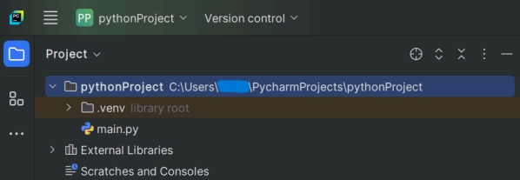

- Type the name of the Python file and make sure the “Python file” option is selected on the mini pop-up window. Now, the new Python file will be created, so you can start coding.
File name: flightpractice.py
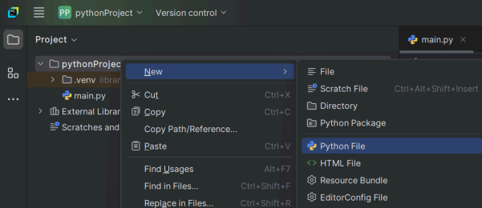
- Type the following code:
from codrone_edu.swarm import *
swarm = Swarm()
swarm.connect()
swarm.takeoff() # drones will take off at the same time
swarm.hover(2) # drones will hover for 2 seconds
swarm.land() # drones will land at the same time
swarm.disconnect()

Light Practice
- Create a new Python file by right-clicking on the project name (highlighted in blue in the image below) that is on the left side of the PyCharm window.
Click on New > Python File.
A mini pop-up window will appear.

- Type the name of the Python file and make sure the “Python file” option is selected on the mini pop-up window. Now, the new Python file will be created, so you can start coding.
File name: ledpractice.py
- Type the following code:
from codrone_edu.swarm import *
NUM_DRONES = 5 #Enter number of drones here
swarm = Swarm(enable_color=False, enable_print=False)
swarm.connect()
for i in range(NUM_DRONES):
#Red
swarm.run_drone(i,"set_drone_LED", r=255, g=0, b=0, brightness=255)
swarm.hover(2)
for i in range(NUM_DRONES): #enter number of drones here
#White
swarm.run_drone(i,"set_drone_LED", r=255, g=255, b=255, brightness=255)
swarm.hover(2)
for i in range(NUM_DRONES): #enter number of drones here
#Blue
swarm.run_drone(i,"set_drone_LED", r=0, g=0, b=255, brightness=255)
swarm.hover(2)
swarm.disconnect()
Practice and Program Show
All students will put their drones in the appropriate location, and we will attempt to swarm all 62 drones with a LIGHT show, FLIGHT show, and then the FINALE!

Light Show

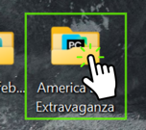
- From the show folder, click on the Light Show folder.
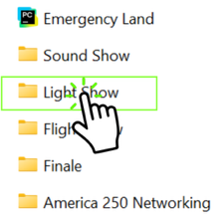

- Double-click on the appropriate file for your number to open the file in PyCharm.
Select the file that corresponds to your table:
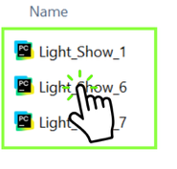
Light_Show_1.py – tables 1 and 2
Light_Show_7.py – tables 3, 4, 5, and 6
Light_Show_6.py – tables 7, 8, and 9

- Run the program.
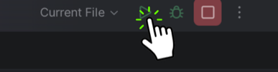

- Make sure your cursor is at the bottom of the screen.

- There will be a 1, 2, 3 count. On 3, click Enter.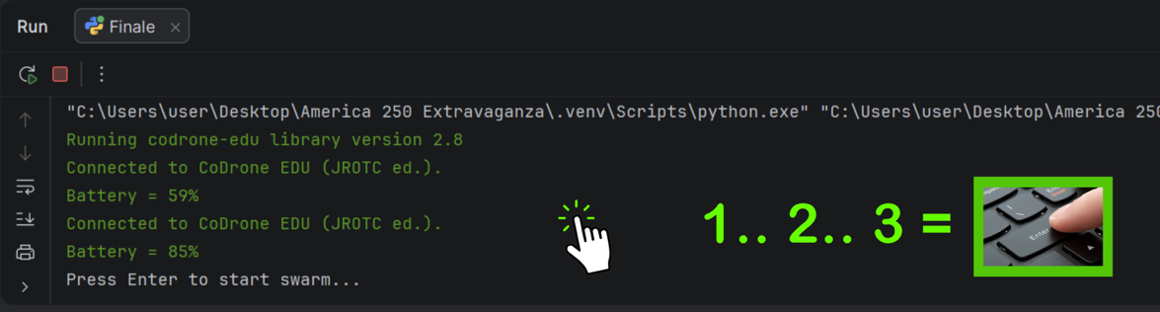

Flight Show

- From the show folder, click on the Flight Show folder.
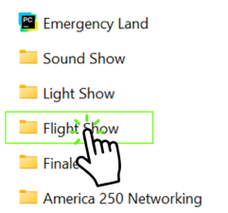

- Double-click on the Simple_Takeoff.py file to open the file in PyCharm.
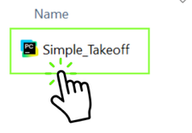
- Run the program.

- Make sure your cursor is at the bottom of the screen.

- There will be a 1, 2, 3 count. On 3, click Enter.

Finale

- From the show folder, click on the Finale folder.
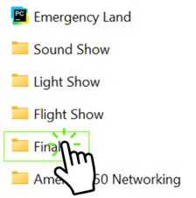

- Double-click on the Finale.py file to open the file in PyCharm.
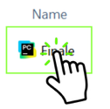

- Run the program.

- Make sure your cursor is at the bottom of the screen.

- There will be a 1, 2, 3 count. On 3, click Enter.

